Linux Beginner Lab – Practical Hands-On Task

🧑‍💻 This lab is designed to help beginners practice all major Linux basics through a single step-by-step hands-on exercise.

# 🔧 Lab Setup Instructions

* - Use any Linux environment (Ubuntu VM, WSL, or Webminal - https://www.webminal.org).
* - Open the terminal and follow each step below in sequence.
* - Use 'man command' or 'command --help' for extra understanding if needed.

# 📁 Step 1: File System Navigation and Information

* - Run: pwd → View your current working directory.
* - Run: ls, ls -l, ls -a → Explore directory contents with various options.
* - Run: cd /tmp → Move to /tmp directory.
* - Run: cd ~ → Return to your home directory.
* - Run: whoami → Check your username.
* - Run: id → Check your user and group IDs.

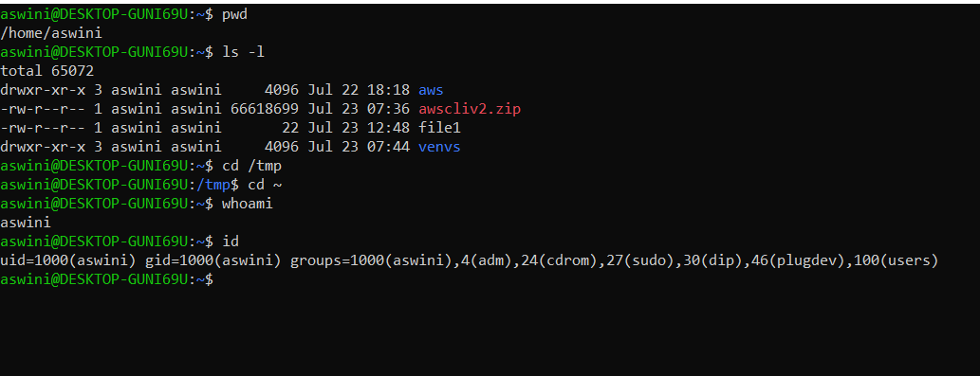

# 📂 Step 2: Create and Manage Files and Directories

* - Create a new directory: mkdir lab_dir
* - Enter the directory: cd lab_dir
* - Create empty files: touch file1.txt file2.txt
* - List files: ls -l
* - Write data into a file: echo 'Linux Lab is Awesome' > notes.txt
* - Display content: cat notes.txt
* - Create a folder inside lab_dir: mkdir backup
* - Copy notes.txt into backup/: cp notes.txt backup/
* - Rename file2.txt: mv file2.txt renamed.txt
* - Delete file1.txt: rm file1.txt
* - Delete backup directory and its contents: rm -r backup

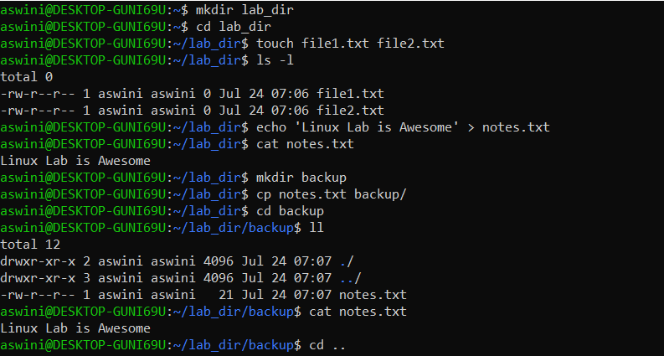

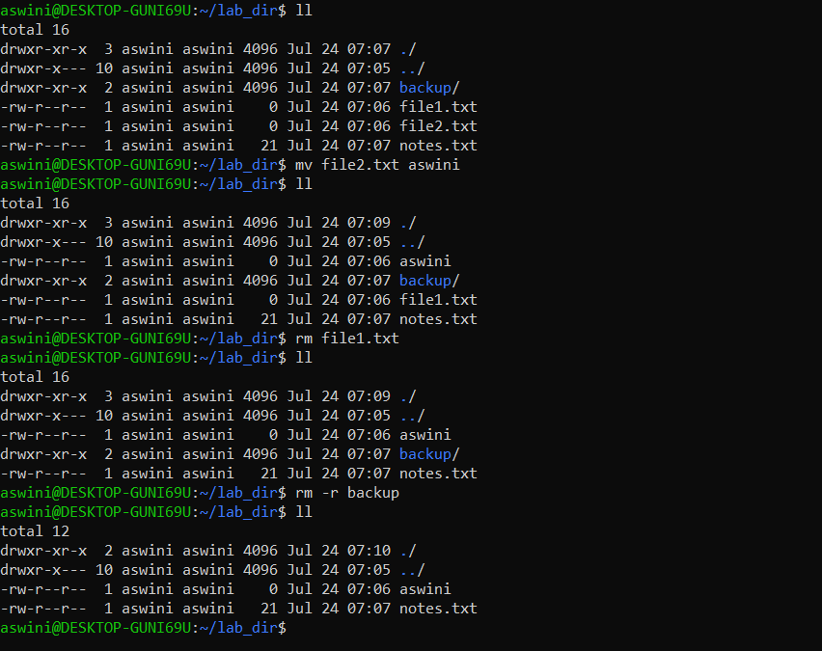

# 🔍 Step 3: Searching and Monitoring

* - Add multiple lines to notes.txt: echo -e 'line1\nline2\nerror found\nline4' > notes.txt
* - Search for 'error': grep 'error' notes.txt
* - Monitor system: top (Press 'q' to quit)

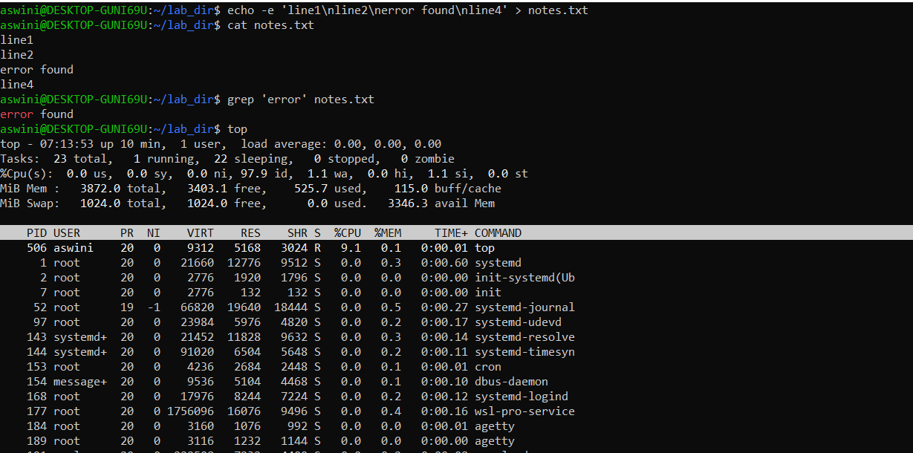

# 🔒 Step 4: Permissions and Execution

* - Create a script: echo 'echo Hello from script!' > test.sh
* - Try to run: ./test.sh → Should fail (permission denied)
* - Grant permission: chmod +x test.sh
* - Run again: ./test.sh → Should succeed

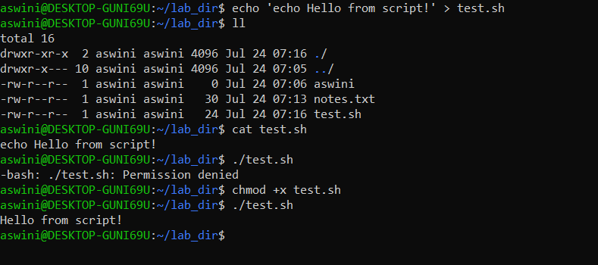

# ⚙️ Step 5: Use sudo (if available)

* - Run: sudo ls /root → (Will work if your user has sudo privileges)
* - Run: sudo cat /etc/shadow → (Only if sudo is permitted; be cautious)

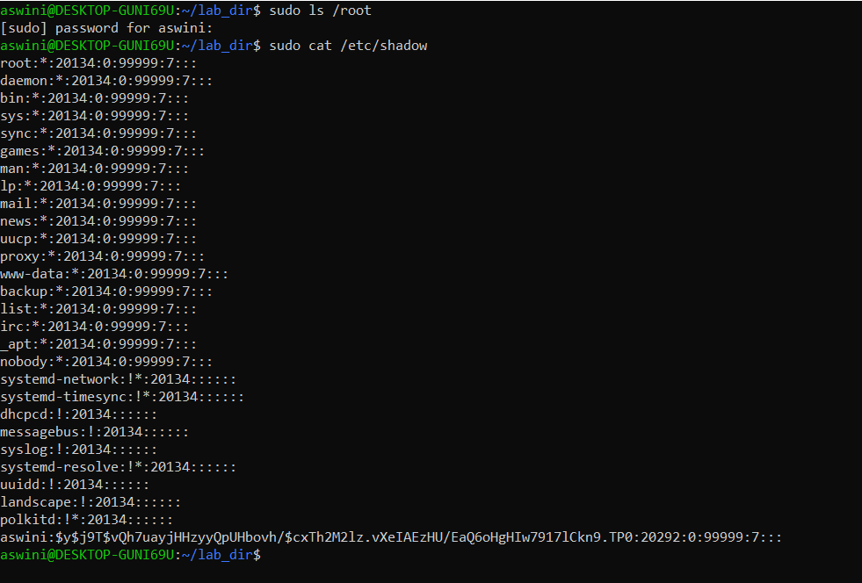

# 🏁 Final Task: Mini Real-World Scenario

* - Create a folder myproject in home directory.
* - Inside it, create a file project.txt with your name and date.
* - Create a subfolder called archive.
* - Copy project.txt into archive/ as project_backup.txt
* - Give read/write permission to everyone: chmod 666 project.txt
* - Remove the original file: rm project.txt
* - Use ls -l and cat to verify everything.

Output :

